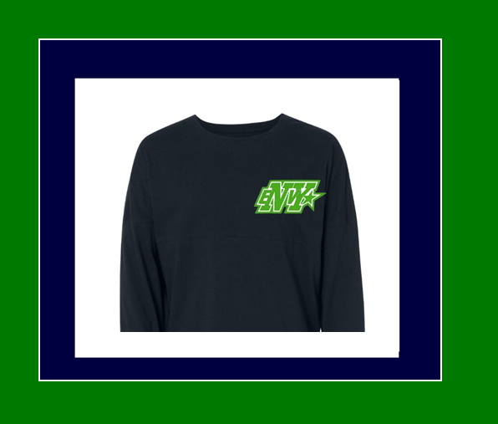

FRONT

Youth Sizes Available: Small, Medium, & Large

Adult Sizes Available: XS, S, M, L, XL, XXL

Name:_______________________________________________________

Size:__________________________________________________________

Team:________________________________________________________

Payment Method:______________________________________________

Email:________________________________________________________

Once all orders are placed we will have an estimated ship date for the product. When orders arrive they will be available for pick in our office.

Don't miss out on cheerleadings hottest apparel trend.

Order yours today.

Orders are due by Friday October 30th, 2015 by 7:00pm

$38.00 For Youth and Adult sizing. (additional $2.00 for XXL)

Buffalo Envy Spirit Jersey's

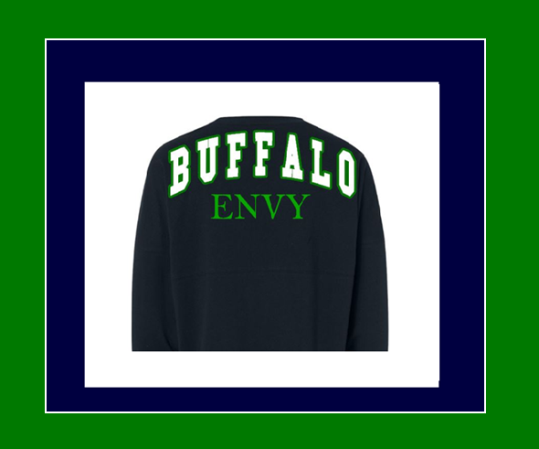

BACK